Chapter 6
SNAPSHOTS AND RESULTS

6.1 RESULT WHEN THE PROGRAM IS INITIALLY EXECUTED

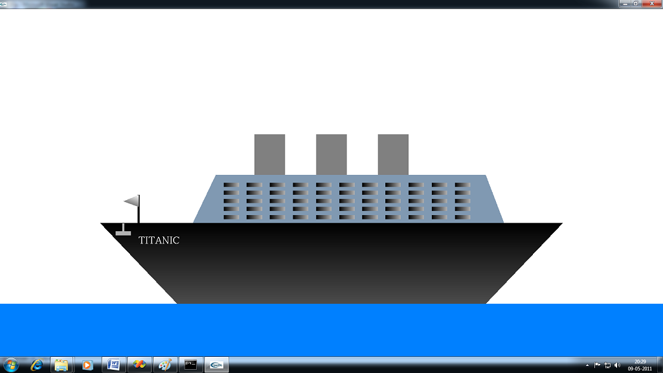
Figure 6.1 Ship at initial execution.
The above snapshot shows the view of the ship when the code is executed initially without giving any input. Initially the ship will be displayed as shown above.

6.2 RESULT WHEN RIGHT BUTTON OF THE MOUSE PRESSED

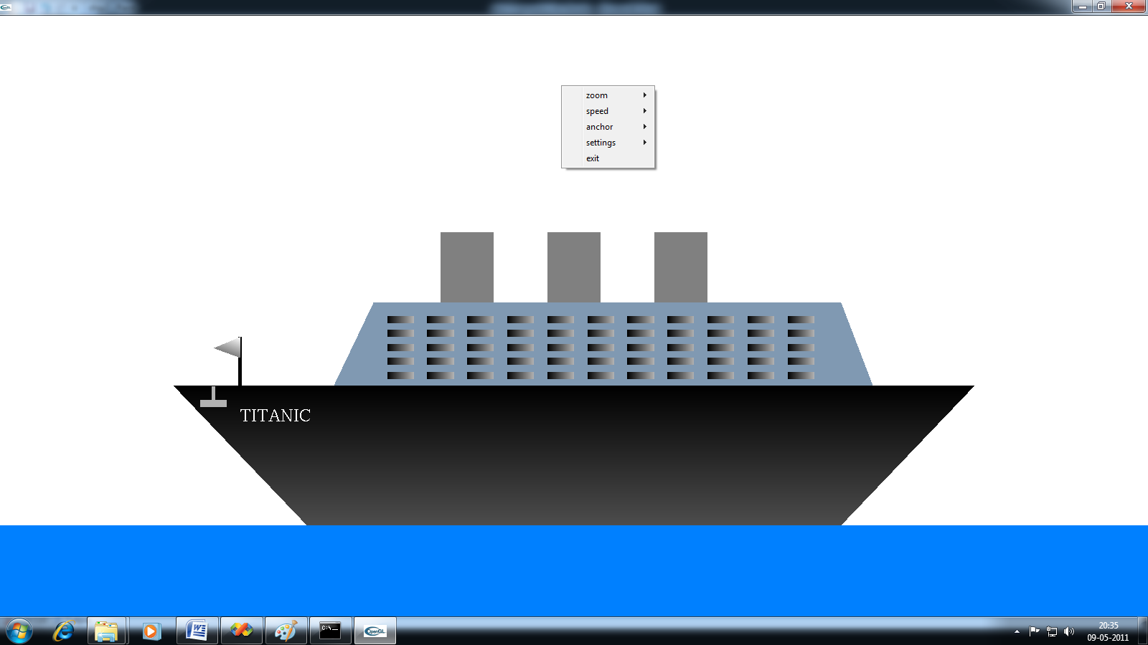
Figure 6.2 Ship with menu
The above snapshot shows the options given in menu. The menu contains submenu also for some of the options. The menu is displayed by right clicking the mouse button.

6.3 RESULT WITH NIGHT EFFECTS

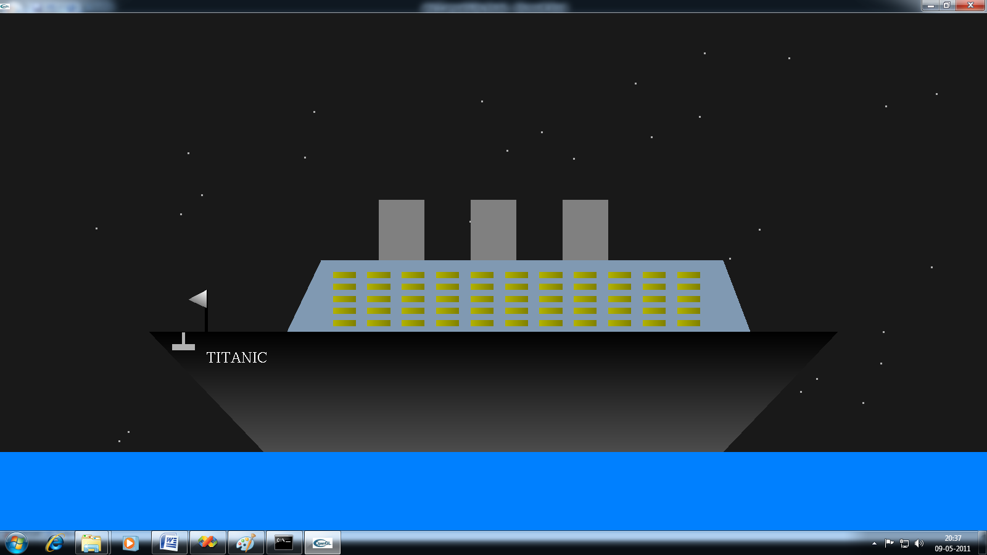
Figure 6.3 Ship in night effects
This snapshots illustrates the output when night effects is active. The light effects in window andstars effect are given. The night effect is selected in menu option.

6.4 RESULT WHEN THE SHIP IS MOVED

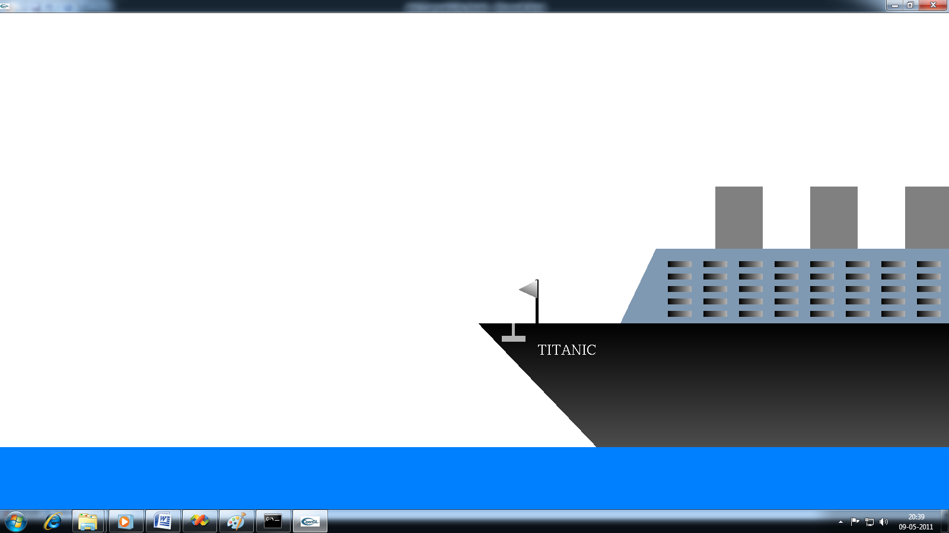

Figure 6.4 When ship is moved through keyboard.
This snapshot illustrates the output of ship when ship is being moved in forward direction through keyboard. The part of ship outside the clipping volume is not displayed.

6.5 RESULT WHEN ZOOM OUT IS USED

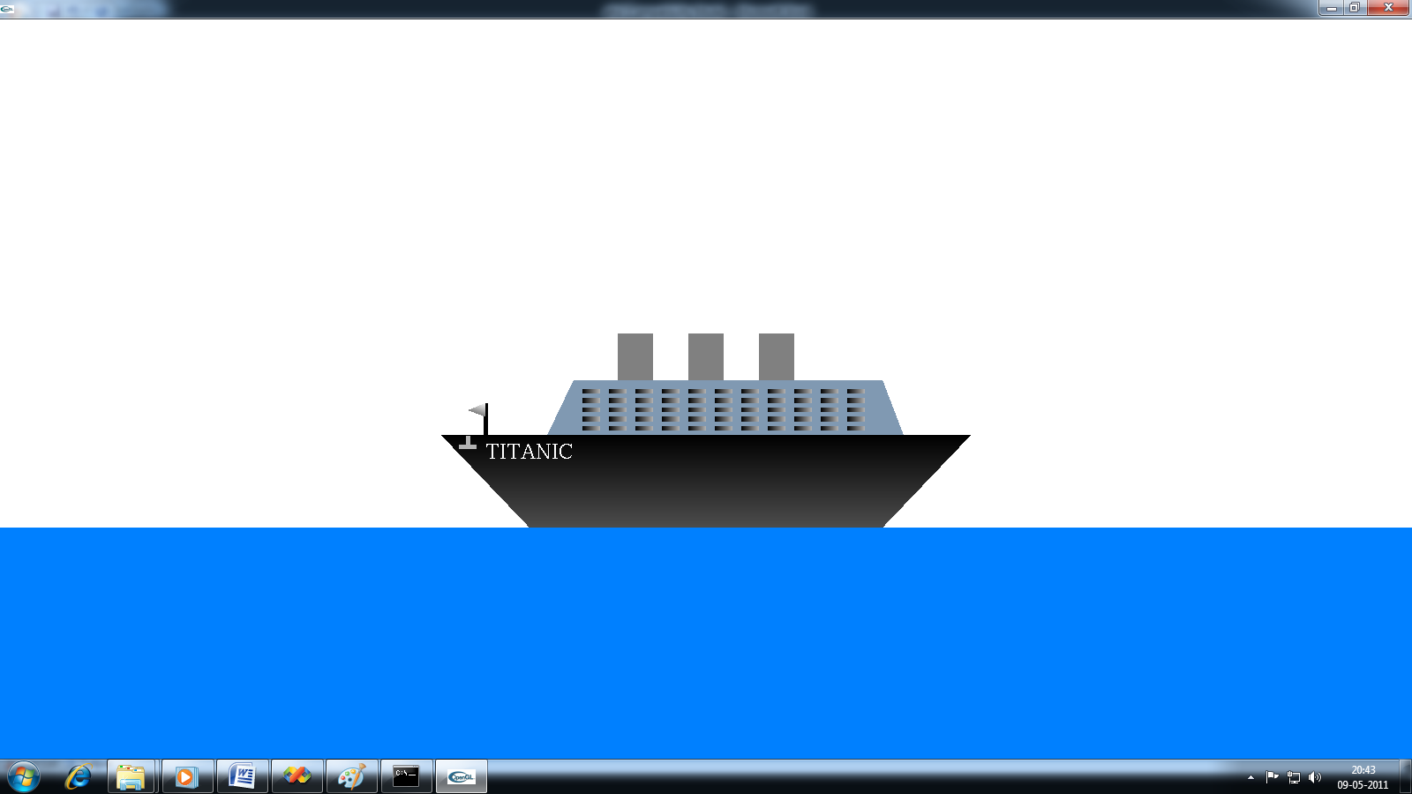
Figure 6.5 View of ship when zoom out is used
The snapshot shown above demonstrates the view of ship when zoom out is used. The zoom out option is given in the menu. The size of the ship is reduced.

6.6 RESULT WHEN ANCHOR IS IN EFFECT

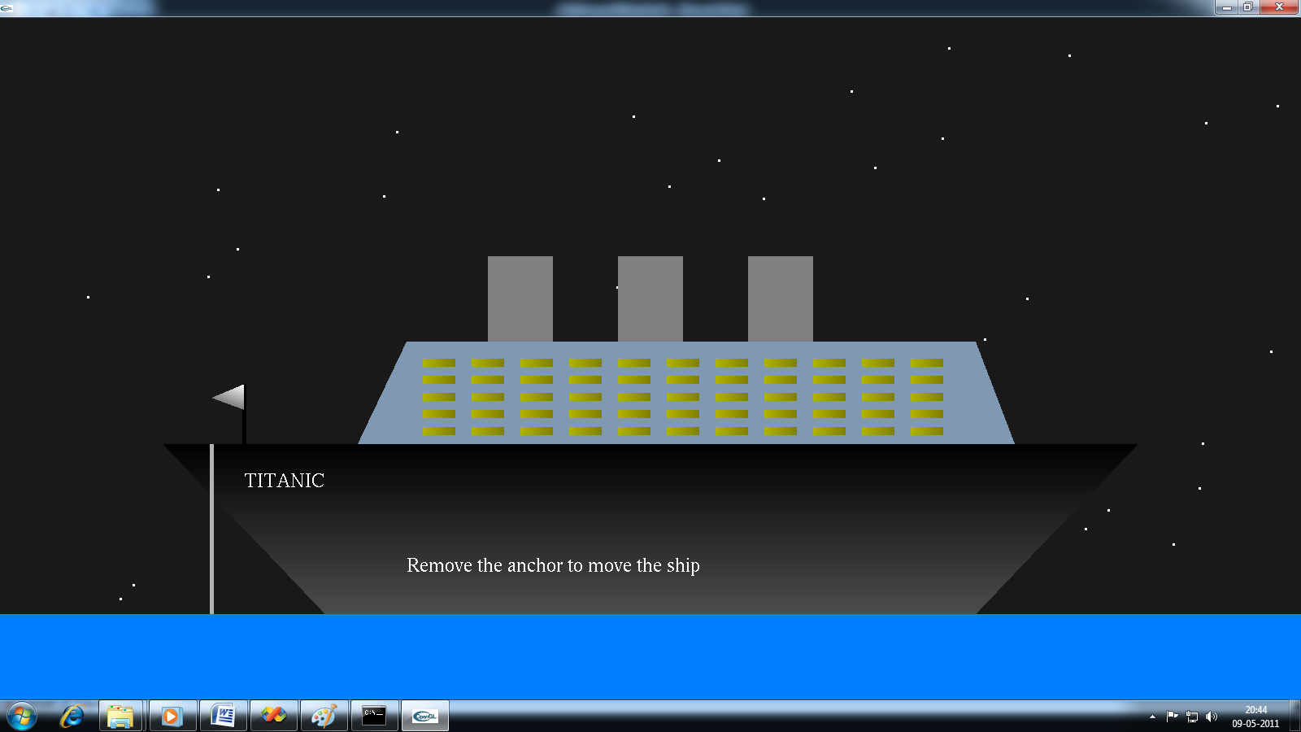
Figure 6.6 Anchor in effect
The above snapshot demonstrates the behavior of ship when anchor is in effect. The anchor is used to restrict the movement of ship. The appropriate message is displayed when user tries to move the ship.

6.7 RESULT WHEN ZOOM IN IS USED

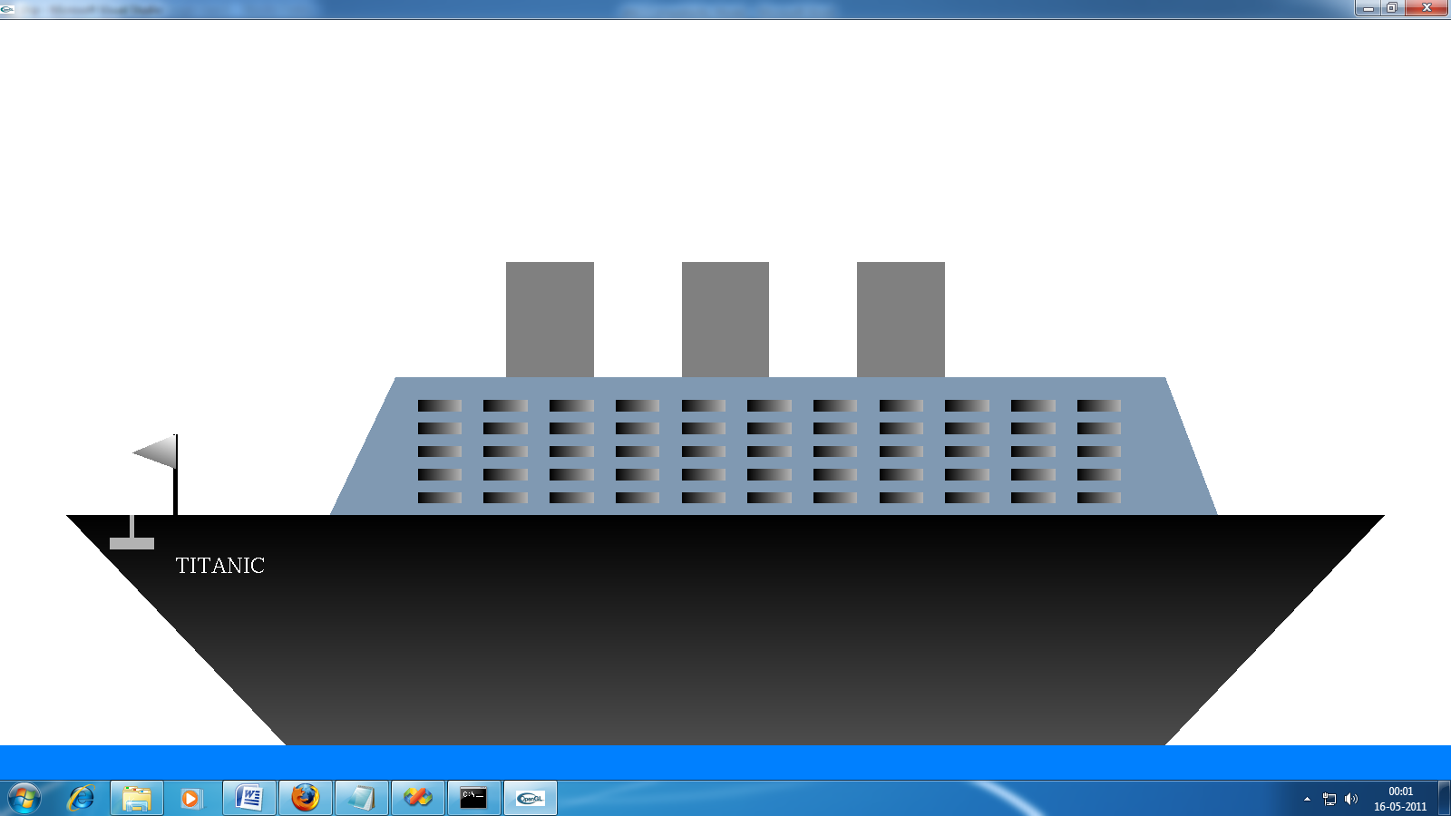
Figure 6.7 View of ship when zoom in is used
The snapshot shown above demonstrates the view of the ship when zoom in is used. The size of the ship is enlarged when the ship is zoomed in. the zoom in option is given in menu.

USER MANUAL
STEPS FOR INSTALLATION OF VISUAL STUDIO
Visual Studio SharePoint workflow features have specific installation requirements.
To use the SharePoint workflow development tools in Visual Studio Tools for Office, complete the following installation steps in the specified order.
- Install Windows Server 2003.
- Install Internet Information Services (IIS). In Control Panel, select Add/Remove Windows components, then Application Server, then Details, then Internet Information Services (IIS).
- Install .NET Framework 2.0 and .NET Framework 3.0.
- In IIS Manager, enable ASP.NET 2.0.5727.
- Install Microsoft Office SharePoint Server 2007. Make sure to run the configuration wizard.
- Install Visual Studio 2005. Use the default installation or make sure that Visual Studio Tools for Office is selected on the Custom installation page of the Setup wizard.
Setup stops and displays an error message, "Setup failed to stop Windows Installer service. You must stop all other applications running Windows Installer service or restart your computer before the installation".
STEPS FOR DEVELOPING A PROJECT
- As soon as the OS gets loaded go to START→ ALL PROGRAMS→MICROSOFT VISUAL STUDIO→MICROSOFT VISUAL STUDIO 2005

- To create a new project go to FILE→NEW PROJECT→ VISUAL C++→select win32 project→give the project name and the destination→OK→select project setting as window application→NEXT→ select Console Application and then select empty project→FINISH

- To create a new file in the project right click on the SOURCE FILE option present in the SOLUTION EXPLORER bar ADD→select NEW ITEM→ select the file type as visual C++→select C++FILE(.CPP)→give the file name with extension .cpp→ADD

STEPS FOR EXECUTION
- To build the project - BUILD→BUILD SOLUTION
- To debug the project - DEBUG→START DEBUGGING

